**SEETHALAKSHMI ACHI COLLEGE FOR WOMEN,**

**PALLATHUR**

**Affiliated by Alagappa University**

**Department of Commerce**

**3rd Yr B.Com.,**

**FINANCE AND ACCOUNTING WITH ZOHO BOOKS**

**TRAVELTRAX TOUR**

**TEAM - TEAM Members:**

**R.Pandimeenal(TEAM Leader)**

**P.Prashanna**

**P.C.Priya**

**P.S.Priyadarshini**

**Overview:**

Welcome to Traveltrax Tour! Our mission is to provide you with the best and most enriching travel experiences. We strive to make every journey extraordinary, from leisurely city to unique rural gateways. Our experienced guides will help you discover breathtaking destinations and learn about the culture, nature,and history in zoho books. We go beyond just sightseeing.

We bring back stories that last a lifetime! Come explore with us and make your travel dreams come true. Traveltrax tour of an unforgettable adventure! The tourism industry, also known as travel industry is linked to people travelling to other locations, either domestically or internationally for leisure, social or business purposes. It is closely connected to the hotel industry,hospitality industry and the transport industry. In zoho books world traveltrax tour reporting a platform in traveltrax tour travel.

**EMPATHY MAP:**

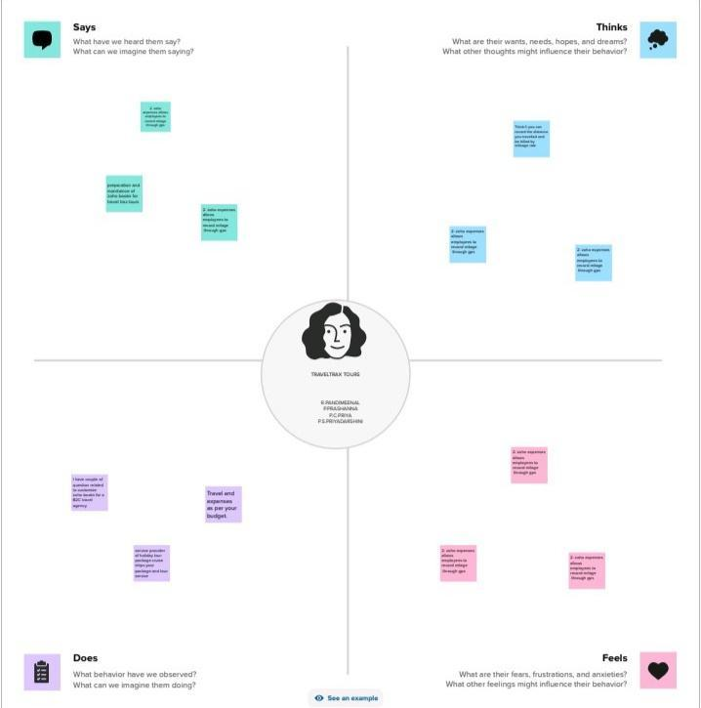

**BRAINSTORMING AND IDEA PRIORITATION:**

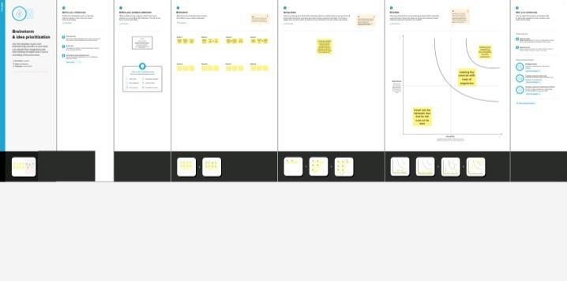

**RESULT:**

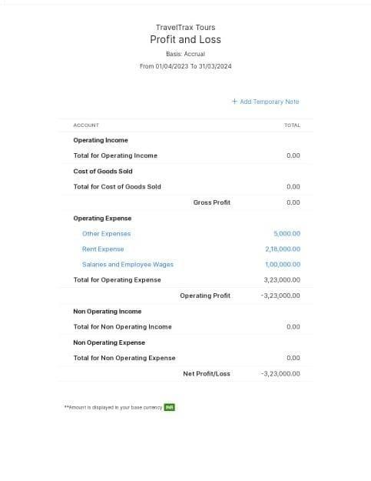

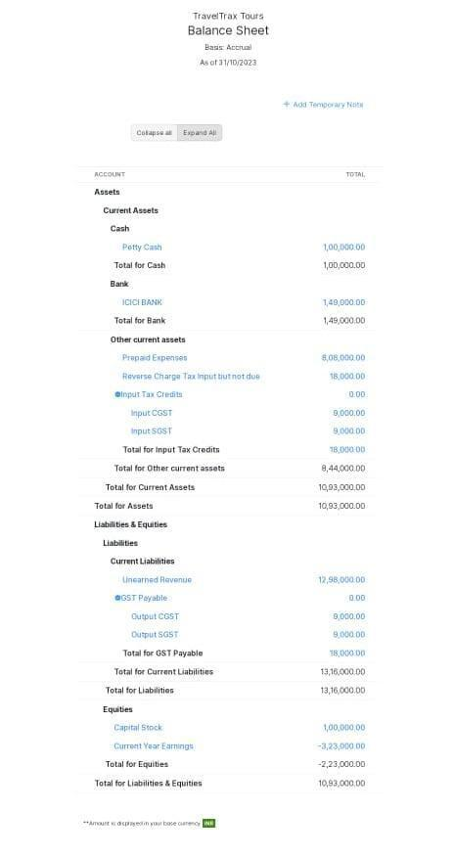

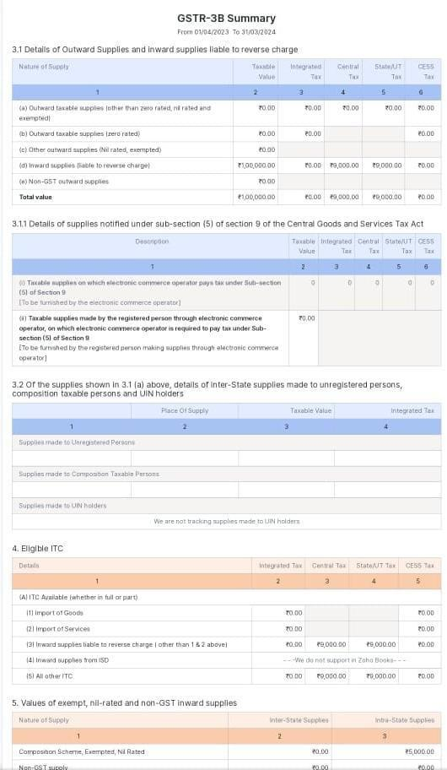

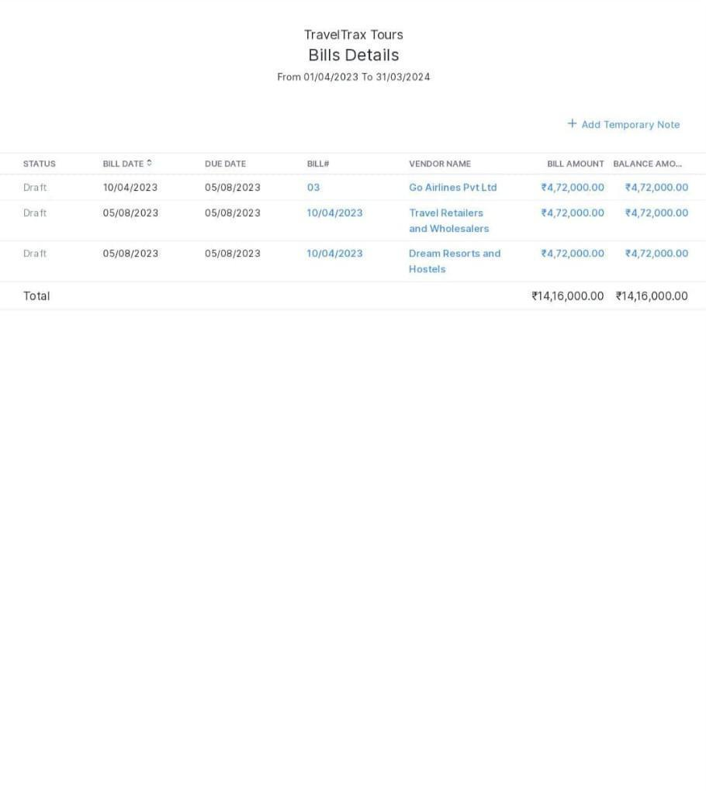

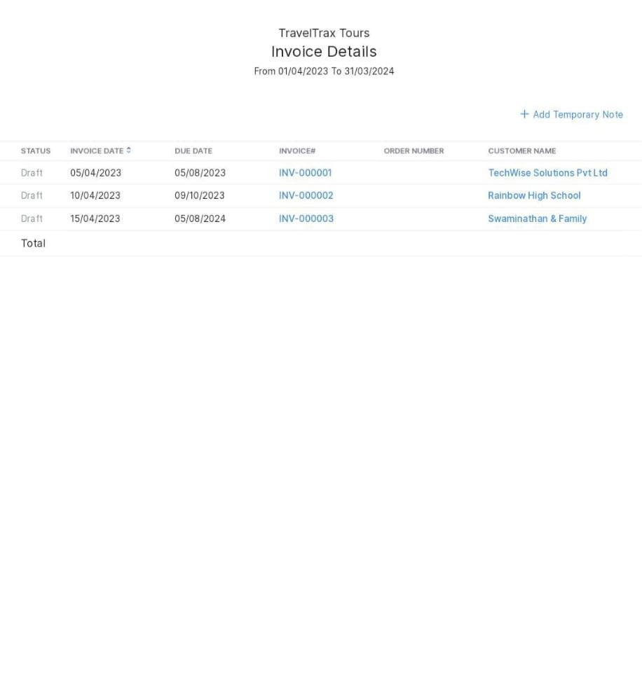

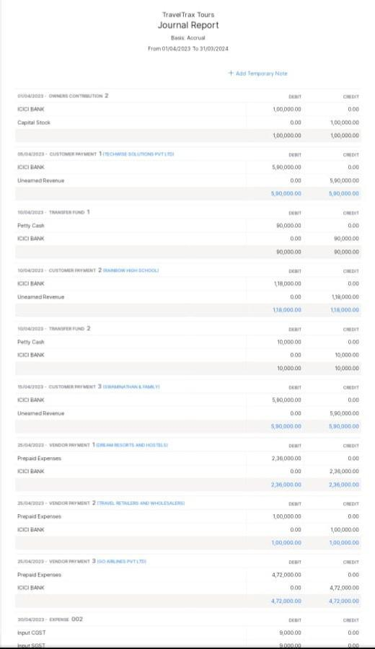

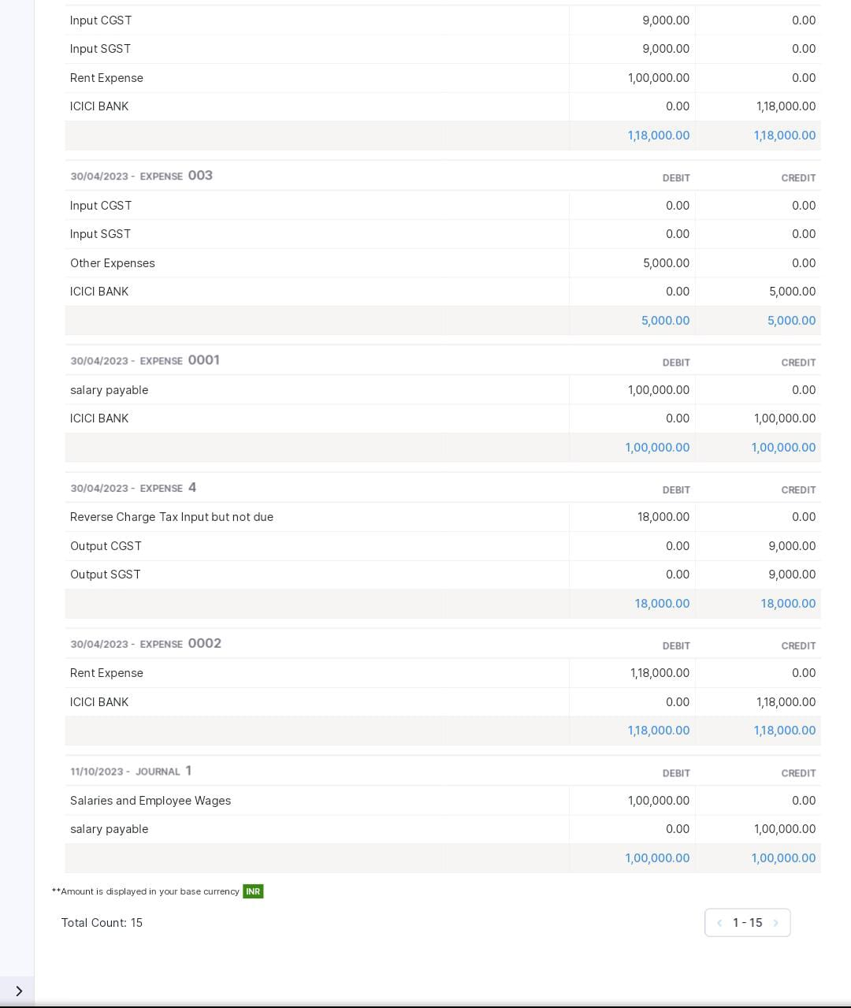

**Advantage:**

Good interior and exterior.

**Disadvantage:**

Missing new version.

**Application:**

Used to maintain the company details and ledger accounts,profit and loss, Account and Balance sheet of the company of traveltrax tour.

**Conclusion:**

Traveltrax tours form features converge by implementing well conceived designs of principles, communities are functioned.

**Future scope:**

In upcoming years, digitalization is the future. Most of the companies are computerized for many reasons. Maintaining accounts are also computerized in future with these new technology preparation of company details. Accounting software was user friendly and it can be adopted.

**Appendix:**

Approved development.

Future assessment.